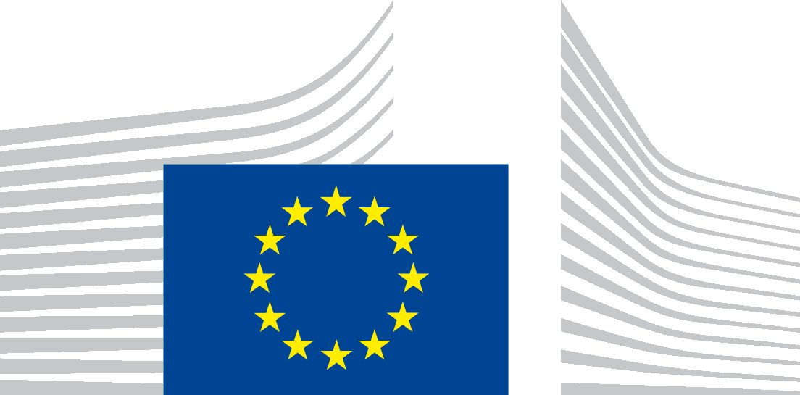 | EUROPEAN COMMISSION  DIRECTORATE-GENERAL JUSTICE and CONSUMERS  Directorate E: Consumers  Unit E.1 : Consumer Policy

Brussels, 22 December 2016

European Consumer Consultative Group (ECCG)
1 December 2016

1. Welcome by the Chair
ECCG approved the draft agenda. The members requested to receive notifications of meetings and the meeting agenda well in advance and to circulate the supporting documents some days before the meeting to allow better preparation. The Commission took note of this request and committed to review the meetings’ preparation modalities. The group was also invited to comment on the Rules and Procedures of the ECCG, which will be discussed and approved in the next meeting.
The ECCG also approved the minutes of the dedicated meeting on REFIT of 18 October 2016.
2. Update on Consumer Policy Actions
The Commission gave a brief summary of recent policy developments, specifically the CPC review, the new approach to business insolvency, the digital single market and the new studies undertaken to improve evidence-based policy making. On the CPC review, members were asked to support the Commission's effort and to send any questions they have on the proposal. As for the new approach to business insolvency, several members expressed their interest in the initiative, while the Luxembourg representative proposed to have a specific discussion on over-indebtedness.
The Commission informed the members that, as a result of the reorganisation of the Directorate-General, the redress and enforcement teams are now merged. The Commission proposed new working methods in order to better improve the work of the group.
3. Update on the Volkswagen Case
The Commission presented the recent actions in the Volkswagen case, thanking the members for their involvement. The Commission encourages the members to continue to send updates on actions undertaken to address the breach of consumer law, especially collective actions.
4. International Product Safety: debriefing and role of the consumer organisations
The Commission gave feedback from the International Product Safety week and referred to the questions for discussion that were sent to members before the meeting, notably on online sale of products and the RAPEX webpage. Several members expressed views on the situation in their respective Member State. Other members stated that product safety is seen as a "mature issue" and that therefore they are welcoming the Commission's efforts to raise awareness on product safety issues with consumer organisations.
5. Digital Single Market Strategy
The Commission presented the proposal for a European Electronic Communications Code and the Wifi4EU proposal. These two proposals, combined with the 5G Action Plan, aim to meet the strategic connectivity objectives for 2025.
The Commission replied to several questions that were raised by the members, further explaining that the WIFI4EU scheme will be open to entities with a public mission – typically local municipalities, libraries, health centres, etc. It will fund the equipment and installation costs (internet access points), while the local entity will pay for the connectivity (internet subscription) and maintenance in good order of the equipment. In any case these infrastructures will not compete with existing ones. The 24 months maximum duration for the initial contract is a maximum, so Member States can set a shorter period.
On cost of international calls, already in 2013 the Commission's Proposal for a Telecoms Single Market included a provision for abolishing unjustified price differences between domestic and international calls, but the EP, Member States and BEREC rejected it. The EECC proposal has refrained from retail price regulation, but foresees structural measures to increase competitive pressure and to reduce the scope for price discrimination (e.g. unification of termination rates). Moreover, the EECC will increase consumer trust in OTT services and hence competitive pressure will trigger new and cheaper international tariff options of telcos. The Universal Service Directive is included in the scope of the new proposal. A definition for bundles has not been included as it would be difficult to find a future-proof definition. On comparison tools, the intention of the Commission is to make it consistent with tools already in use in other sectors.
6. Progress of the REFIT Fitness Check of EU consumer and marketing law, following
European Consumer Summit
The Commission presented an overview of the progress and future steps of the Fitness Check, in particular the outcome of the European Consumer Summit (17 October 2016) and the online public consultation (12 May – 12 September 2016) as well as the current findings of the external studies which will be completed by February 2017. The Fitness Check Report will be adopted and published in spring 2017, together with the underlying studies and announcement of follow-up actions.
In the public consultation, the Commission received 436 replies (at least one per country). About 50 respondents also submitted policy papers. 20 replies came from the consumer organisations. Participants of the Consumer Summit seemed to be of the opinion that the current EU consumer and marketing law remains largely fit for purpose. Enforcement should be stepped up and the consumers' and traders' awareness about their rights and duties should be increased. Targeted amendments to the existing directives should nevertheless be considered, possibly bringing them into a single regulatory instrument, provided the level of consumer protection is not reduced and the necessary margin of manoeuvre is left to the MS to tackle national specificities.
7. Developing the partnerships with local associations to promote the awareness of
consumer rights and increase digital skills of (vulnerable) consumers

a) Presentation of Digital Competence Framework for Consumers and its possible uses by consumer associations

The Commission presented DigCompConsumers, a joint initiative between DG JUST and JRC, a reference framework for education and consumer policy professionals that describes the competences consumers need to operate in digital markets in terms of learning outcomes.
Research shows that consumers who have better digital skills are more empowered, and empowered consumers contribute to the efficiency of (digital) markets. Education actors are likely to be more open to dealing with consumer issues when relating to digital competence as this is high on the education agenda. The main uses of the framework are in consumer education, including for gap analysis in consumer education materials, as a support for teaching plan and curriculum development, and as a basis for surveys to measure digital skills of population groups.
A summary report of the framework has been published at
https://ec.europa.eu/jrc/en/digcompconsumers

The full report, which includes proficiency level and usage option will be published on DG JUST website.

b) Presentation of the outcomes of ex-post evaluation of the Consumer Credit Campaign
The Commission presented the results of an awareness-raising campaign about Consumer Credit Rights in Austria and the Czech Republic run by DG JUST. The evaluation concluded that the aim of this campaign was relevant for the two countries involved and the principle of working in partnership with stakeholders (including credit providers too) was appropriate.
c) Presentation of the Consumer Rights Campaign
The Commission gave a presentation on the Consumer Rights Campaign carried out in 2014-2015 to increase general awareness of the existing EU legal instruments, in particular the CRD (Consumer Rights Directive), in partnership with consumer and business associations and national consumer authorities. The main findings were that the campaign was effective, especially when supported by good partners in Member States and efficient, because, thanks to the means of promotion, the potential audience was very high.
Several Members expressed the opinion that the campaign's success was, to a considerable extent, due to the knowledge and co-operation of consumer organisations in the MS concerned.
The ANEC Member informed the members that they did a survey in 2014-2015 on online shopping to assess whether consumers knew their rights. The results were that only 2.2% felt confident regarding the required knowledge and only 10% replied correctly to the questionnaire on online shopping.
The Commission appreciated ANEC sharing this experience and expressed the commitment to come back on this issue in the future.
8. Ways to enhance the cooperation with ECCG members
The Commission described the collaborative tool currently in use by the CPC network as an example of how to enhance the communication within the ECCG Group and to introduce a more dynamic way of working in order to exchange information in an easy and practical way. This system, that is called Wiki, is composed of a mix of Word, Excel, Facebook and Outlook and gives the possibility to get any sort of relevant information and to share documents with all people registered.
The BEUC Member reminded that BEUC also has a similar networking platform under the Consumer Champion project. This is a platform for consumer professionals and could also potentially used by the ECCG members to the group’s purposes. The Commission explained that the BEUC’s proposed tool seem to be more open platform for the use of all professionals while the Commission proposed tool would be more internal, limited only to the ECCG members. However, the Commission promised to look at that too.
9. Matters raised by the ECCG Members
The LU Member shared his concerns regarding the role consumer policy has played so far in the EU and what benefits it has delivered so far. He remarked that the EU should stop self-bashing and to better promote the achievements. He called for a dedicated discussion on this issue. The BEUC and other Members intervened in the discussion which also touched upon the REFIT exercise and the levels of the law harmonisation, role of consumer organisations, consumer information and engagement.
It has been agreed to have a dedicated meeting on this issue in February 2017.

